LESSON 2

**MODULE 1: What is Machine Learning?**

* **Machine Learning**

A data science technique used to extract patterns from data, allowing computers to identify related data, and forecast future outcomes, behaviours, and trends.

* **Traditional Programming Paradigm**

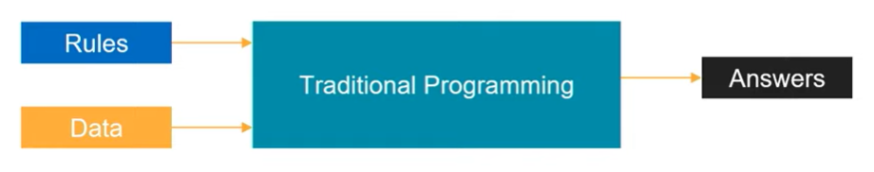

* **Machine Learning Paradigm**

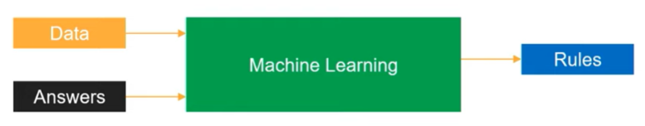

* Machine Learning uses historical data to generate rules that we have not thought of.
* Machine Learning is best suited for tasks like pattern recognition, anomaly detection, time series forecasting and recommendation systems.

**MODULE 2: Applications of Machine Learning**

* Machine Learning/ Deep Learning/ Reinforcement Learning
  + Natural Language Processing (NLP)
    - Text: summarization, topic detection, similarity, search
    - Speech: speech-to-text, text-to-speech, translation
  + Computer Vision (CV)
    - Self-driving cars
    - Image classification
    - Object detection
    - Object identification
    - LIDAR and Visible Spectrum
  + Analytics
    - Regression
    - Classification
    - Forecasting
    - Clustering
  + Decision Making
    - Sequence decision making problems
    - Recommenders
* Examples of Machine Learning
  + Automating the recognising the disease.
    - [Google has trained a deep learning model to detect breast cancer](https://www.mercurynews.com/2017/03/03/google-computers-trained-to-detect-cancer/)
    - [Stanford researchers have used deep learning models to diagnose skin cancer](https://news.stanford.edu/2017/01/25/artificial-intelligence-used-identify-skin-cancer/)
  + Recommend next best actions for individual care plans using patient’s digital health footprint.
    - [EMRs (Electronic Medical Records) and EHRs (Electronic Health Records)](https://en.wikipedia.org/wiki/Electronic_health_record)
    - [IBM Watson Oncology](https://www.ibm.com/products/clinical-decision-support-oncology)
  + Enabling real-time, personalized and interactive banking experience with chat bots. This allows resolving simple issues without the need of human intervention.
    - <https://www.drift.com/learn/chatbot/ai-chatbots/>
  + Identify next best action for the customer (ex: showing relevant deals).
    - [Sentiment analysis](https://www.concur.com/newsroom/article/machine-learning-with-heart-how-sentiment-analysis-can-help-your)
  + Capture, prioritise and route service requests to correct employee to improve response times (ex: feedback mails received from the customers can be forwarded to the concerned department by looking at the content of the mail.)
    - Introduction to Ticket Routing using AI <https://monkeylearn.com/blog/ticket-routing/>